AA’s Got Talent 2026
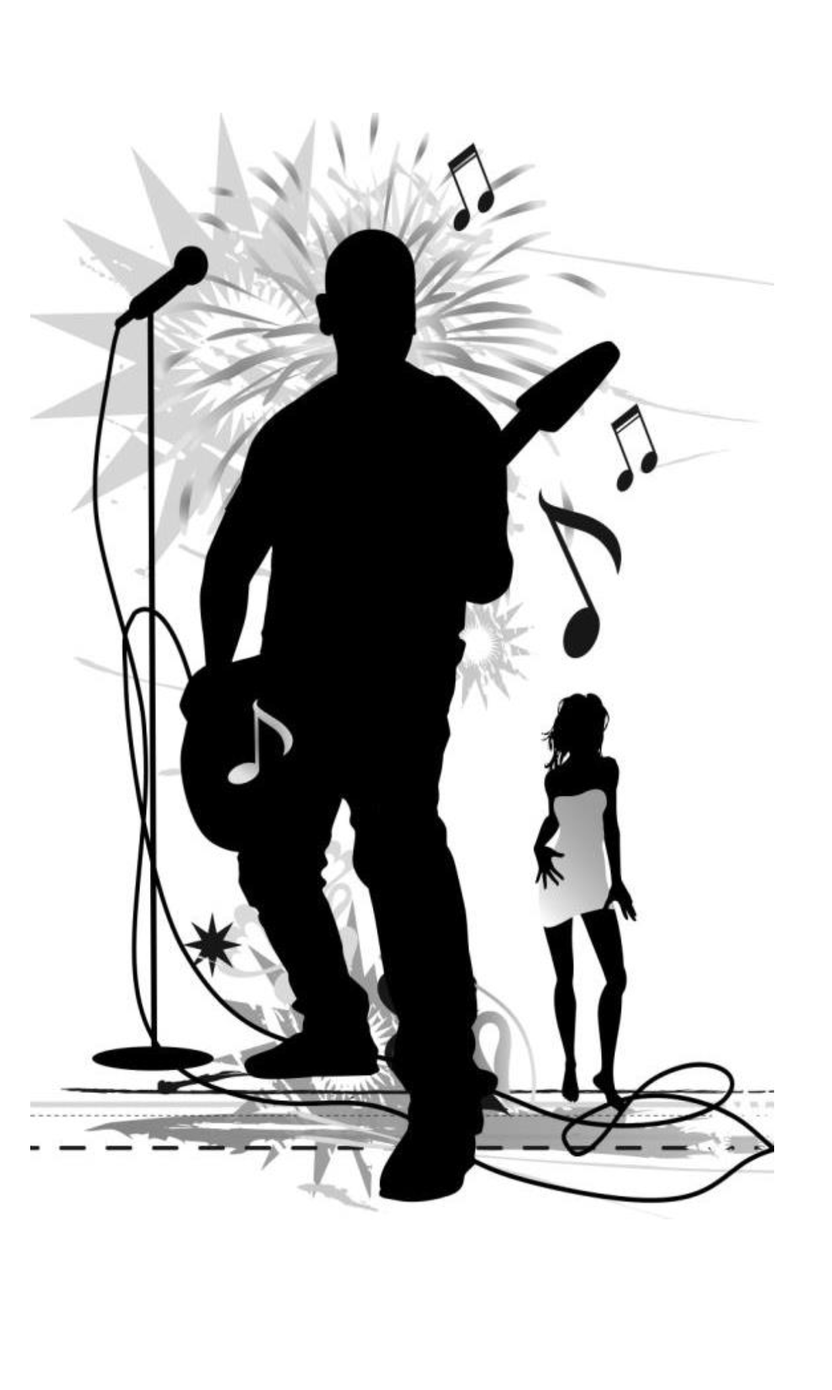
1st Planning meeting: 12:30 PM
Saturday, October 25th at 441 Group
Show which will take place in February.

Volunteers needed for
- Desserts
- Water Sales
- Decorations
- Clean-up
- Ticket sales
- Greeters
- Raffle Sales

PERFORMERS:
Limited number of acts allowed. No bands. Each act gets 3 minutes to perform and must attend a planning meeting to sign-up and/or audition.

DO YOU HAVE TALENT?
Singers, dancers, musicians, rappers, comics welcome. Please get signed up and help us have a fun adult event!

AA’s Got Talent is a fundraiser for Broward County Intergroup and all performers must purchase tickets to attend.

